Jev vs the LLMs: Benchmarking Results for Document Review
How big does a model need to be to label an email? Today's frontier models have more than 2 trillion parameters, and can write code, reason across long contexts, pass bar exams, and generate remarkably fluent prose. TypeSafe AI's position is that, for many classification and automation tasks, using an LLM is like crushing an ant with a sledgehammer. On September 15, 2026, they released Jev 1.13, a model designed specifically for large-scale classification and automation tasks.TypeSafe AI
Jev achieves similar levels of intelligence on System One tasks compared to existing LLMs, while being two orders of magnitude faster and more efficient. While Jev gives up string generation, it’s optimized for structured outputs and can’t hallucinate. -TypeSafe AI
Before you roll your eyes at another AI launch thread, there may be something to this. The race to vibe the coolest Jev v LLM bakeoff has produced some compelling examples. The following comes from: https://typesafe.aihttps://typesafe.ai
Minimize image
Edit image
Delete image
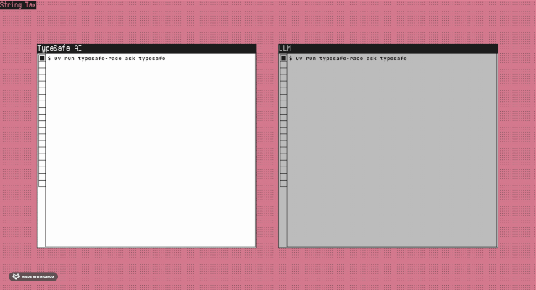
But you've heard "better, faster and cheaper" before, and I'm not sure if vibe-GIFs hold up in court yet. It may be the world's fastest sock sorting machine, but can it make complex legal determinations at scale? It's 2026 and we know better than to judge a model by hype alone.
But let's also not be impulsively dismissive. Whether it's Jev or another model, we know the technology is evolving in one direction, and we should be prepared for disruption. So let's find out if there's a there there.

What does "good enough" mean for document review?
As most of my readers are aware, in complex litigation, document review involves lawyers making legal determinations against large populations of documents that ultimately determine what gets produced to an opposing party or regulator. Traditionally, lawyers use platforms like Relativity to apply case-specific rules for responsiveness, privilege and other issues, which wind up as labels in a database. So we are talking about labeling emails (and other types of electronically stored information or ESI), but we're not talking about triaging help desk tickets.
With typical review populations in the millions, human review has given way to various iterations of technology assisted review (TAR), including supervised and unsupervised ML and LLM-based workflows. Courts began accepting TAR in 2012, when Judge Peck approved the use of predictive coding in Da Silva Moore v. Publicis Groupe, and Judge Peck later observed in Rio Tinto that it was now “black letter law” that courts permit TAR when the process is reasonable and transparent. Since then, TAR adoption has climbed, as has the use of sample-based validation to validate results and defend its use. Today, most large cases involve an agreement between parties that allows for the use of TAR, sometimes subject to transparency and validation disclosures. While there is no legal precedent for the "minimum passing rate" for a TAR project, a 70-80% recall floor is a common rule of thumb.

Enter the LLMs
In the last two years, LLM-powered document review has come on the scene as an alternative to traditional TAR models. Today, all leading eDiscovery platforms offer LLM-based document review, some with built-in statistical validation. While they function differently, LLMs essentially function as a new engine in a traditional TAR 1-style workflow, with certain practical differences such as prompt iteration rather than human-labeled training documents. As argued by Tara Emory, Jeremy Pickens and Wilzette Louis in the Sedona Conference Journal article, “TAR 1 Reference Model: An Established Framework Unifying Traditional and GenAI Approaches to Technology-Assisted Review,” courts have thus far treated LLM-based review as a form of TAR, subject to no more or less scrutiny than a traditional TAR workflow. In Schulte v. LinkedIn Corp., for example, a federal court treated Relativity aiR as TAR, though the decision is non-precedential. As a result, most practitioners apply the same "rule of thumb" recall floor of 70-80% to LLM-based review.Tara EmoryJeremy PickensWilzette Louis
To be clear, if you're a lawyer conducting a review for production (human, LLM or Jev), there is more to consider than recall and precision. The legal obligation is not to hit a magic F1 score; it is to conduct a reasonable, proportional, defensible search under the Federal Rules and the Sedona Principles. That means thinking about the stakes of the case, the likely richness of the population, privilege risk, validation design, quality control, transparency, and whether the process is good enough for the discovery problem in front of you. Likewise, if you're a data scientist evaluating a new AI model, there's more to think about than recall and precision. As such, this isn't meant to be a verdict on Jev, so much as it is to answer the question "is there a there there?".

Experimental setup
To keep the bakeoff practical, we ran the same TREC email-review tasks through Jev and a set of general-purpose LLMs, then compared accuracy, latency, cost, and stability. We compared Jev against seven commercially available language models: Haiku 4.5, Sonnet 5, GPT-5.6 Luna and Terra, Gemini 3.5 Flash-Lite and 3.8 Flash, and a locally-run Gemma 3 12B, and measured the results on four dimensions that matter in review: recall, precision, speed, and stability.
- Recall: % of relevant document the model correctly marked as relevant
- Precision: % of documents the model marked as relevant that are actually relevant
- Speed: median latency to score one document
- Cost: $ per 100,000 documents
- Stability: How often a model will produce a different output given identical inputs
We chose to use TREC 2016, since it's well known in the legal industry, with ground truth labeled by a panel of NIST assessors. According to TechCrunch, TypeSafe founder Diogo Almeida says Jev is trained exclusively on synthetic data using a technique he calls "reinforcement learning from calibrated decisions." That reduces concern that Jev saw the Bush emails during training, though public benchmark contamination remains a possible issue for frontier LLMs.
We had each model review each document for eleven scored topics. A twelfth topic, Eminent Domain, was dropped because assessor agreement was too low. The final evaluation set included 3,016 emails: topic positives, 1,000 judged non-relevant emails, and 1,000 random emails, excluding the separate calibration set. Note that the sample is enriched relative to the full population, making it closer to a typical eDiscovery review set than to a raw collection.
For each topic, we wrote the criteria once from the NIST topic text, refined them once on a separate 668-email calibration set, and then froze them before running the evaluation. Every model received the same frozen decision criteria. Jev was tested through three question types: Noul, a yes/no classification primitive; Choice, a forced-choice primitive; and Score, a numeric scale primitive. We also tested Facets, our composed configuration that asks multiple Noul sub-questions and takes the maximum/logical OR. For example, on the Faith-Based Initiatives topic, the core question is whether the email concerns grants or funding to faith-based agencies for social services; the penumbra includes adjacent initiatives, partnerships, or policies for delivering social services through religious organizations, but not generic religious references or prayer breakfasts. Facets let us represent that core-and-penumbra structure explicitly. Jev can still be wrong, but it cannot answer outside the labels or scale the workflow provides. It also does not provide a rationale unless the workflow supplies one.
From the TREC 2016 population, we sampled 3,016 emails for the evaluation set, combining positives for the selected topics with 1,000 judged non-relevant emails and 1,000 random emails, while excluding the calibration set used to refine the criteria.
With that setup out of the way, here is what happened.

Speed
If you seen other posts about Jev, this part shouldn't be surprising. It's really fast. Because decision models are built to return small, structured answers rather than compose long strings of text, they can turn decisions around far faster than their more contemplative LLM cousins. Below is the average per-document round-trip time to tag the eleven TREC issues listed above.
Minimize image
Edit image
Delete image
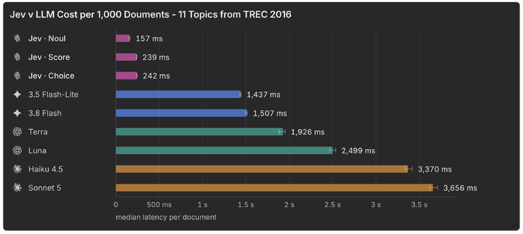
Faster? Check.

Cost
Like speed, Jev has a significant advantage here as well. That is partly because Jev returns compact structured decisions rather than generating long output tokens. We priced the Jev configurations as tested: Noul, Choice, Score, and the multi-question Facets setup. Below is the cost per thousand documents to review for the eleven TREC issues.
Minimize image
Edit image
Delete image
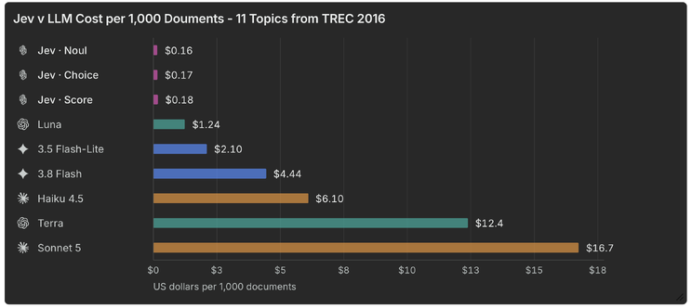
So far so good, but there are a lot of things faster and cheaper than LLMs that can't do what LLMs can do.

Recall and precision
What you really came here for. As background, recall and precision were computed against TREC’s NIST assessor labels: recall is the share of relevant documents our workflow found, and precision is the share of documents it marked relevant that were actually relevant in the assessed set. Looking at the results, our first takeaway was honest surprise that Jev was even competitive with the LLMs at all. As you can see, all three runs exceeded 75% recall, while outperforming some LLMs by more than 10% in precision.
Minimize image
Edit image
Delete image
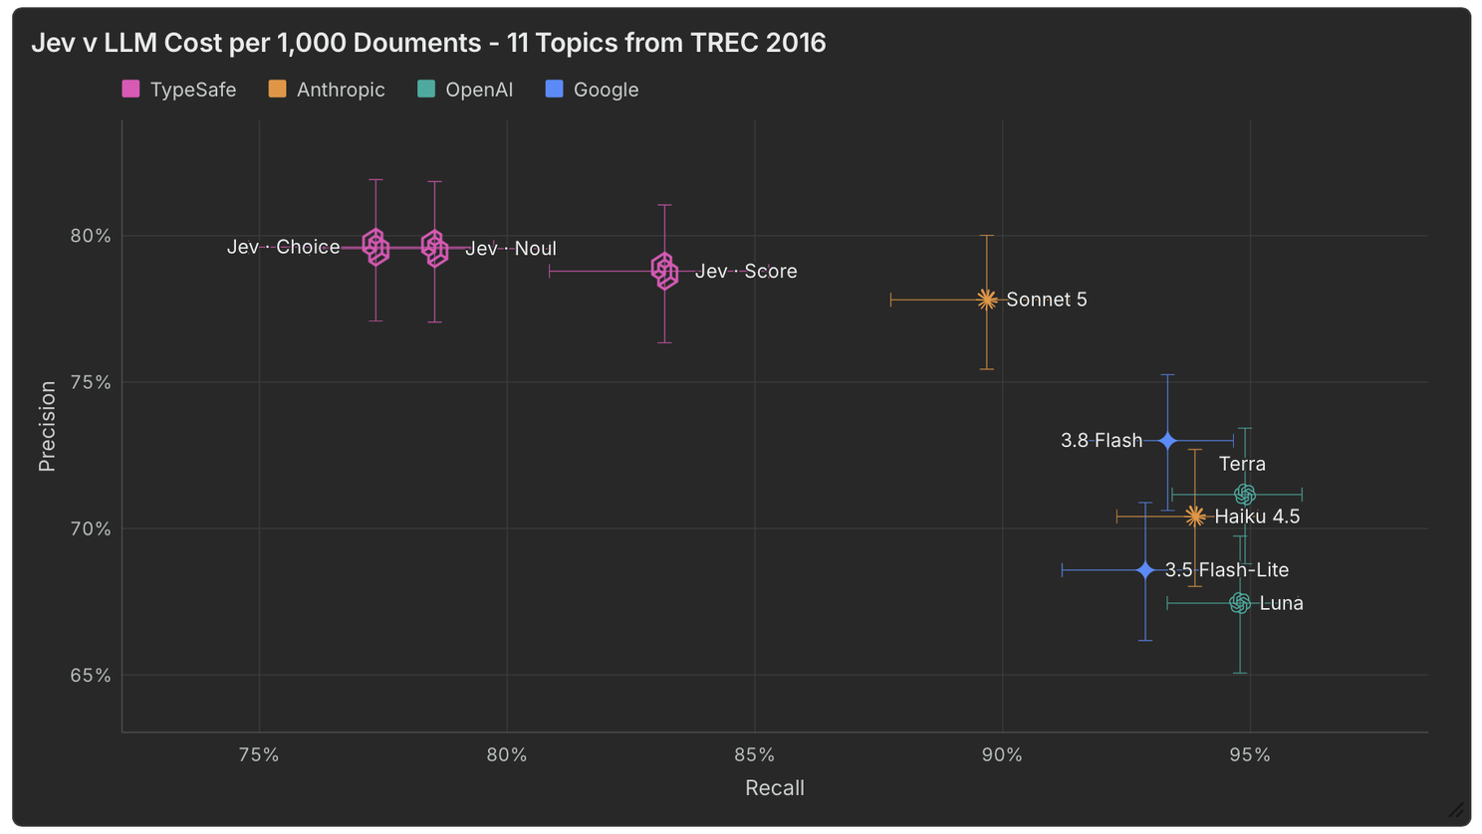
You can see that the results varied my mode, with "score" performing best of the three "out of the box" modes. As a reminder, the prompts were not iterated upon, so we consider these results a floor for what might be possible.
Beyond recall and precision, we tested the stability, or determinism of each model by sending the same 300 emails through each model five times and counting pairwise disagreements between runs. Like humans, non-deterministic models can produce different outputs from identical inputs. We measure this for our LLM models and were curious how Jev would stack up. Here, Jev demonstrates significantly more deterministic behavior than its LLM counterparts, meaning outputs are more consistent between runs.
Minimize image
Edit image
Delete image
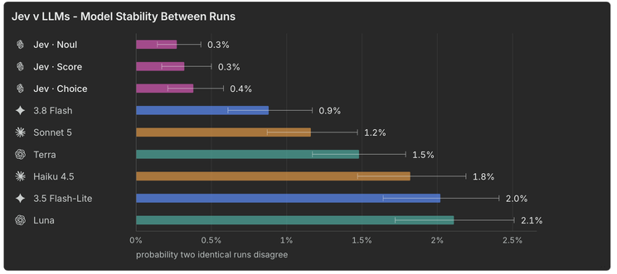

What might be possible
Using the three primitives, there is a lot of room for creativity. We tested several composed configurations that had varying degrees of success. One strategy we call "facets" boosted recall to 88.9% while still remaining above 75% precision. No doubt, there is a lot of room for exploration and service provider differentiation here and the best approach will likely vary with each project.
Minimize image
Edit image
Delete image
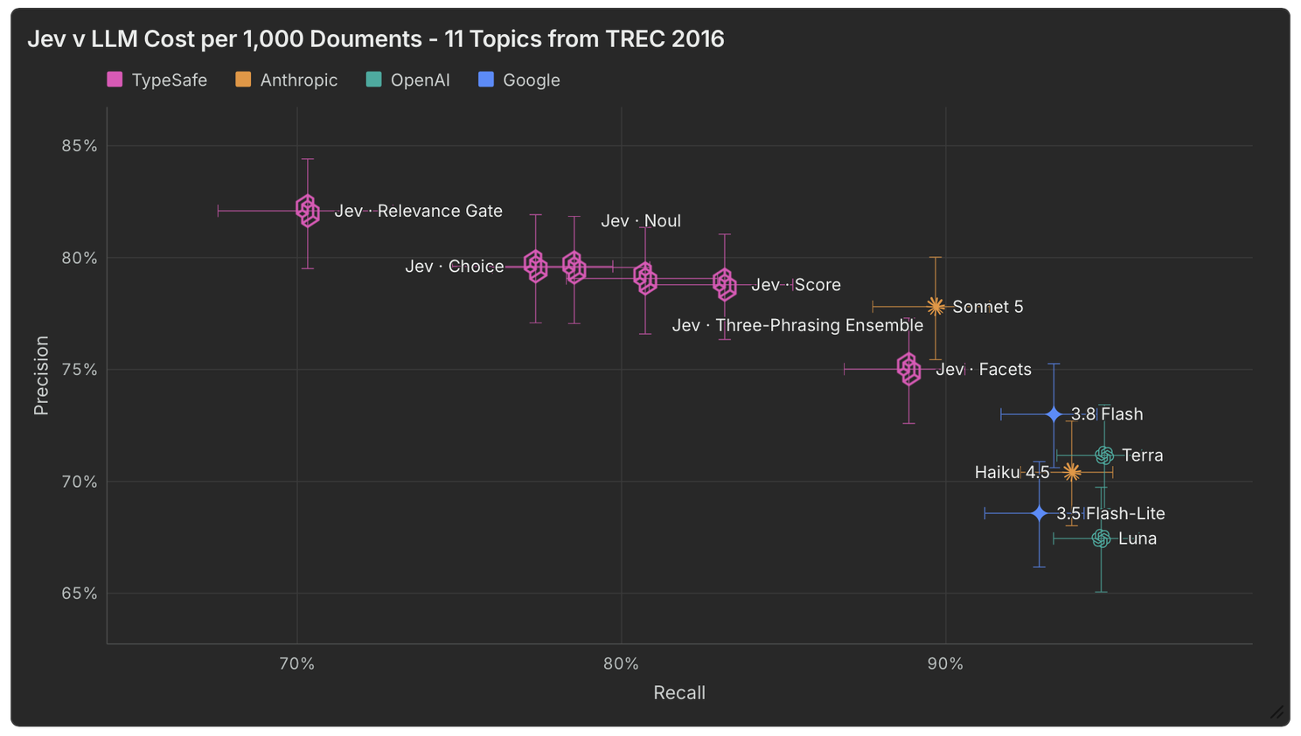
Recall and precision aside, Jev's latency, cost and flip rate was significantly lower than its deeper thinking LLM counterparts.

Beyond first pass review
If Jev can make relevance determinations at scale for roughly $15.60 per 100,000 documents in about 157 milliseconds per document for Noul, the opportunity is bigger than first-pass relevance review. At list prices, 150 Noul classifications across one million documents would cost about $23,400; by comparison, running the cheapest LLM we tested across the same 150 million decisions would be roughly $315,000. Jev could replace keyword search. Jev could enrich and accelerate early case assessment (ECA).
Outside of document review, Jev could show promise quality controlling, validating citations, enriching large data sets, and doing many other use cases. The more you think, the more ideas start to flow. A recent study by researchers at Carnegie Mellon University found that, "comparing jev-as-a-judge with sixteen generative and reward-model judges, with blinded human adjudication, we find it within three percentage points of a state-of-the-art LLM judge."
Maximize image
Edit image
Delete image
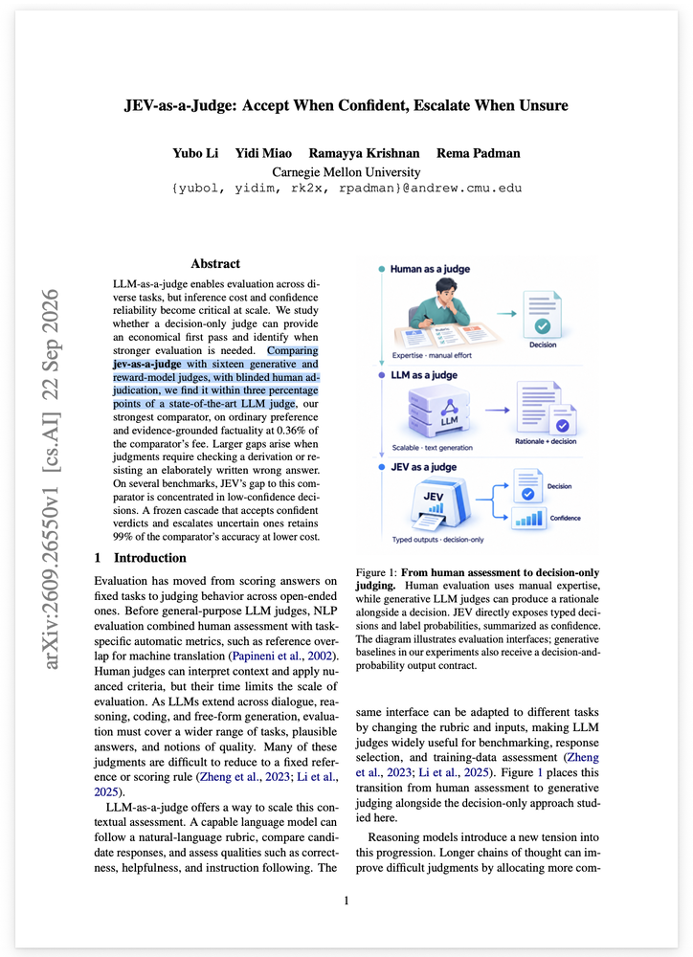

Limitations and Unknowns
Jev is designed specifically for classification and automated decision making. Unlike LLMs, it does not respond to user queries with written answers. Research, drafting, summarization, chatbots, copilots, coding agents, and other human-in-the-loop workflows are better for LLMs. Even for classification, there are likely projects that require more depth and context than Jev currently offers. Some LLM review tools also provide more than a binary relevance call. Relativity aiR for Review, for example, can surface rationales, considerations, and citations that help a reviewer understand why the model reached a conclusion. Jev is built for bounded decisions, not that kind of explanatory review experience.

Who should care about Jev?
Jev is not a SaaS eDiscovery platform. Jev is a new model that software companies like Relativity are surely evaluating to learn more about what it is and isn't good at. If you're an applied scientist or developer looking to test a new model against your current baseline, it might be worth giving Jev a serious look. As of this writing, Jev is available through TypeSafe’s direct API rather than as an off-the-shelf option inside Azure, AWS, or the major eDiscovery platforms. If you are adventurous, the interesting question is not whether Jev replaces your review platform tomorrow. It is whether a small, fast decision model can become one of the engines inside the next generation of legal workflows.Relativity

Conclusion
When it comes to relevance review, Jev may not yet be "better", but it is certainly "cheaper" and "faster", and, depending on the user case, may be at "good enough". The results we've shared should not be treated as a verdict on whether Jev is viable for your workflows. But, at a minimum, we hope they add color to the conversation and spur more research and experimentation. As we used to say about LLMs, this is the "worst the technology will ever be". What a fun time to be in legal technology!

Title Brainstorming
Jev vs TREC 2016: Benchmarking Results for Document Review
Zero-Shot Throwdown: Benchmarking Jev vs the LLMs at Document Review
Benchmarking Jev vs the LLMs: Are Decision Models Ready for eDiscovery?
Jev vs the LLMs: Preliminary Experiments

